Skill 4
Task 1 process synchronization and child process monitering using waitpid()
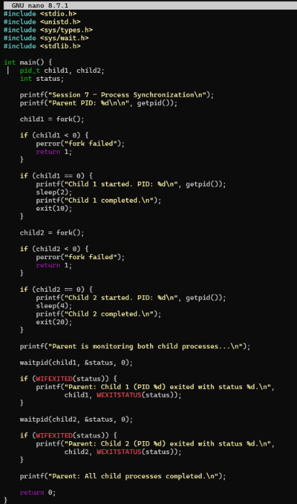
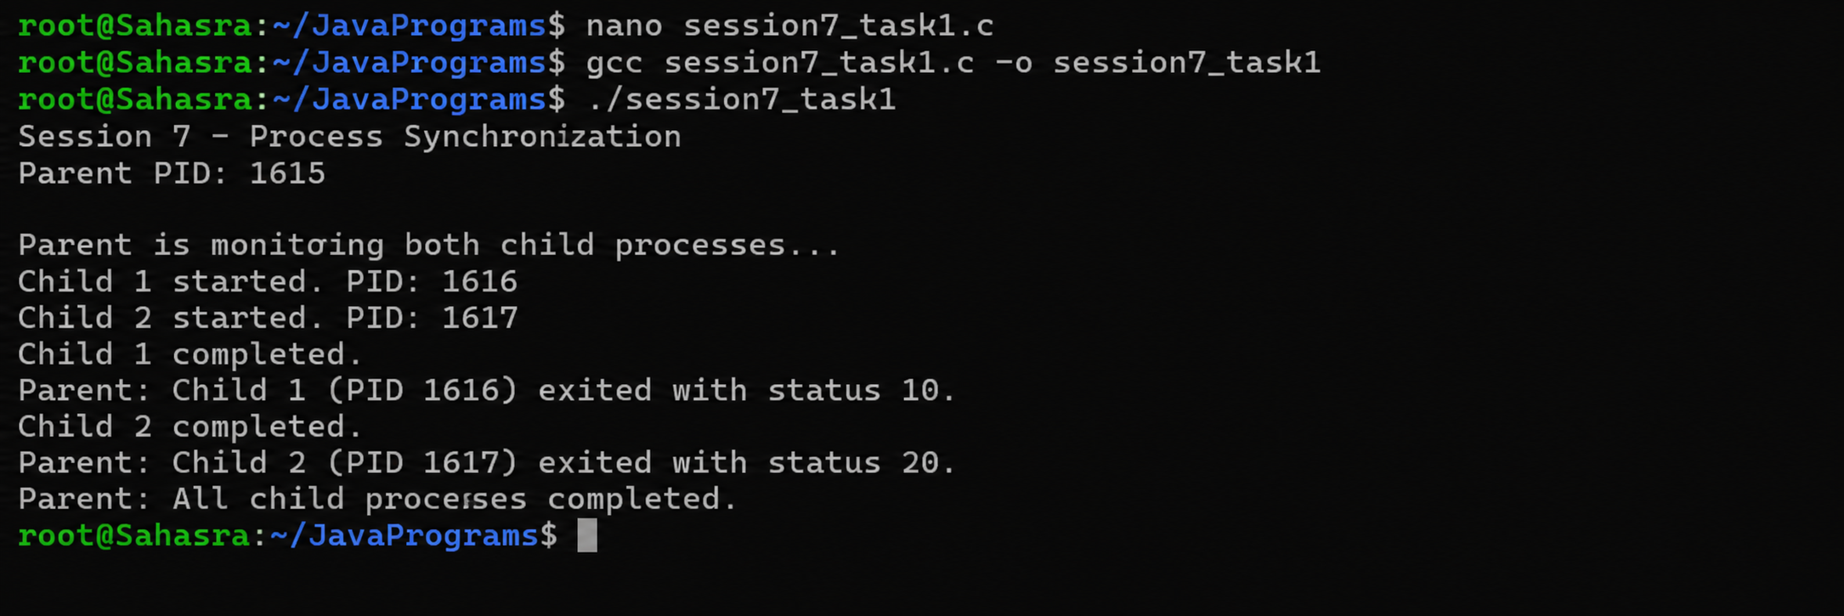

TASK 2: To Retrieve PATH Variable, Parse Search Directories, Locate Executables, Verify Permissions, Handle Missing Commands, Test Command Resolution
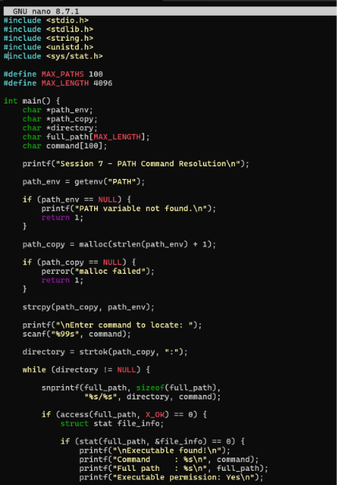
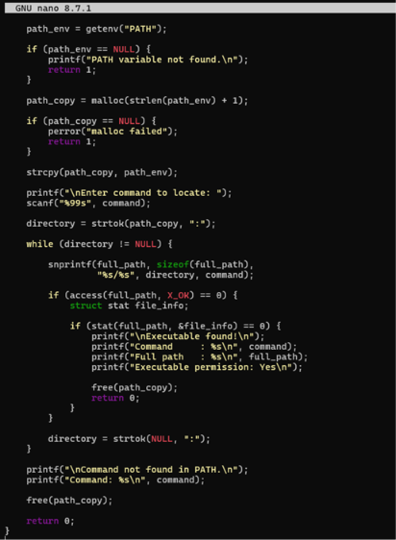
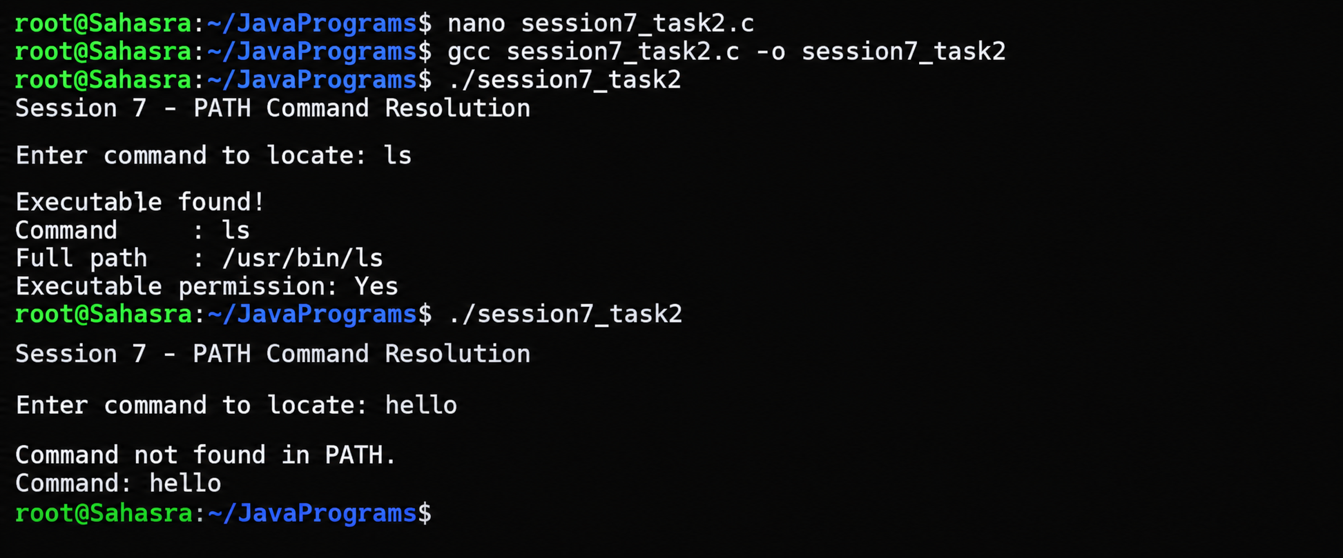

Session – 8 TASK 1: To Detect Variable References, Expand Values, Handle Undefined Variables, Update Tokens, Support Nested Variables, Test Expansion Logic

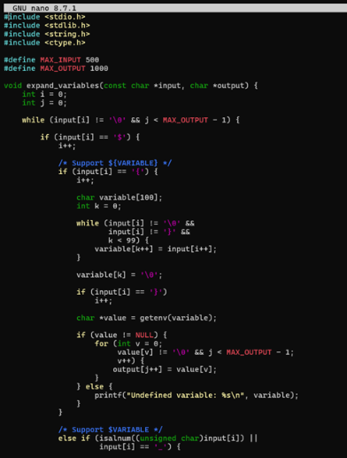
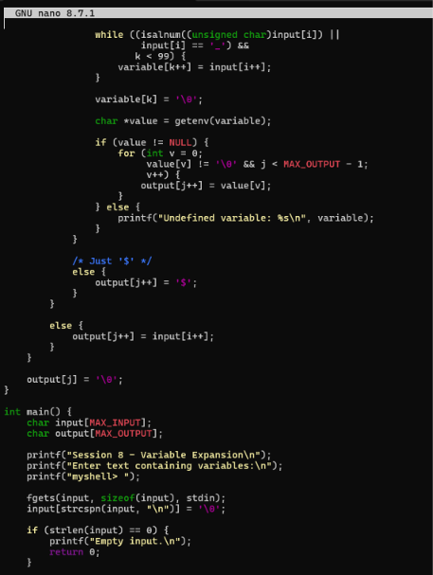
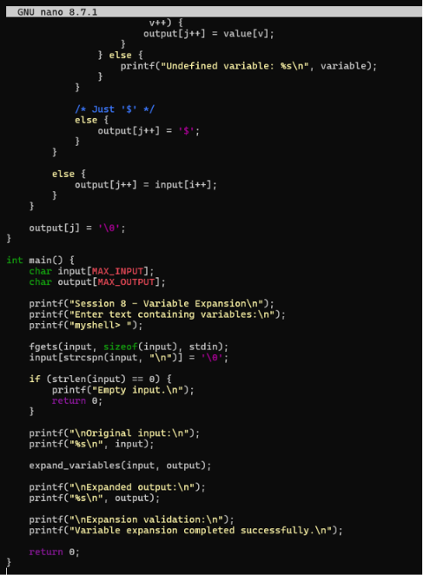
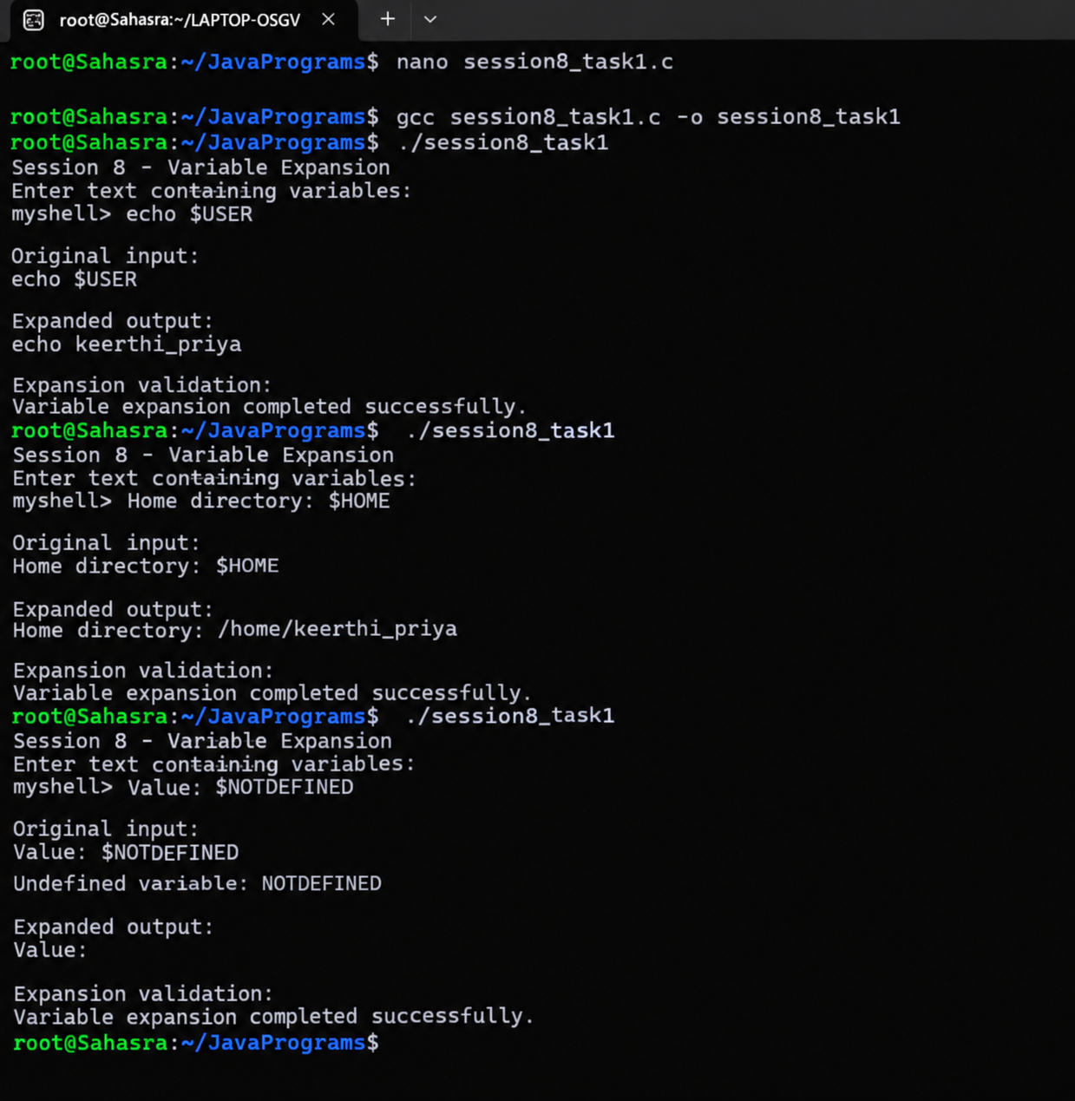

TASK 2: To Identify Built-ins, Create Dispatch Table, Execute In- Process Commands, Handle Invalid Commands, Maintain State, Test Dispatch Logic
